UI field too long
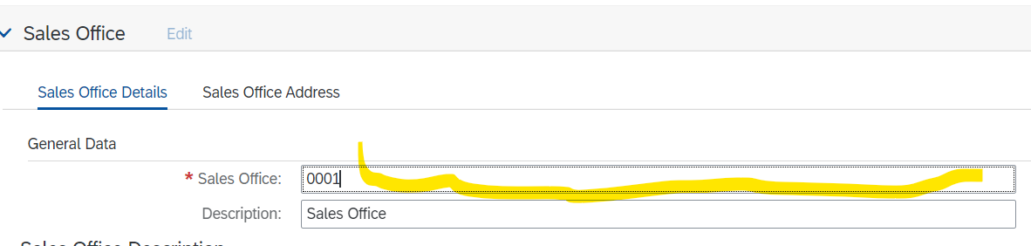

Country Code Missing
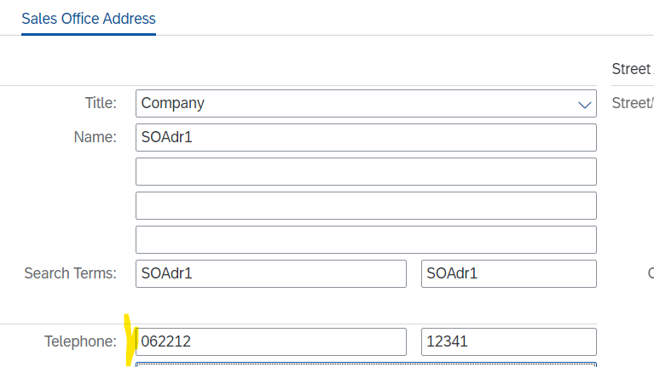

No check on mandatory field Country Code
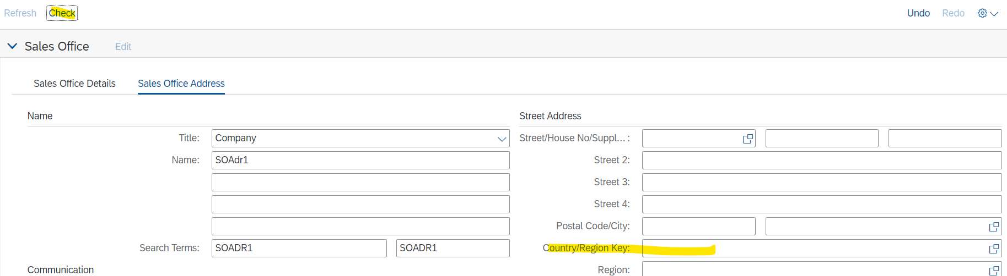

F4 Help on Street?
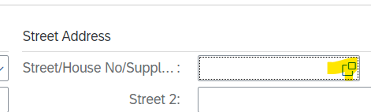

And on City

Other things to be done
Niklas: add to Fiori Launchpad
Ulla: German translation

